低碳园区计算系统配置步骤

1: download these two softwares and install

Links: <https://www.microsoft.com/zh-cn/evalcenter/evaluate-sql-server-2019?filetype=EXE>

<https://docs.microsoft.com/zh-cn/sql/ssms/download-sql-server-management-studio-ssms?redirectedfrom=MSDN&view=sql-server-ver16>

2: install the SQL 2019, waiting

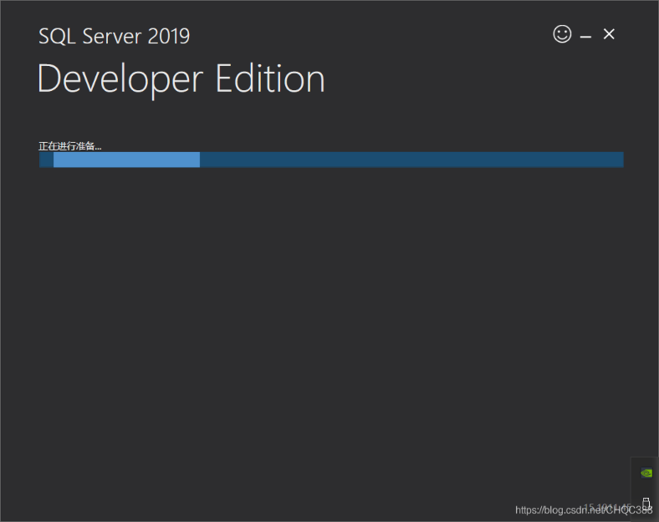

3、Choose the using version

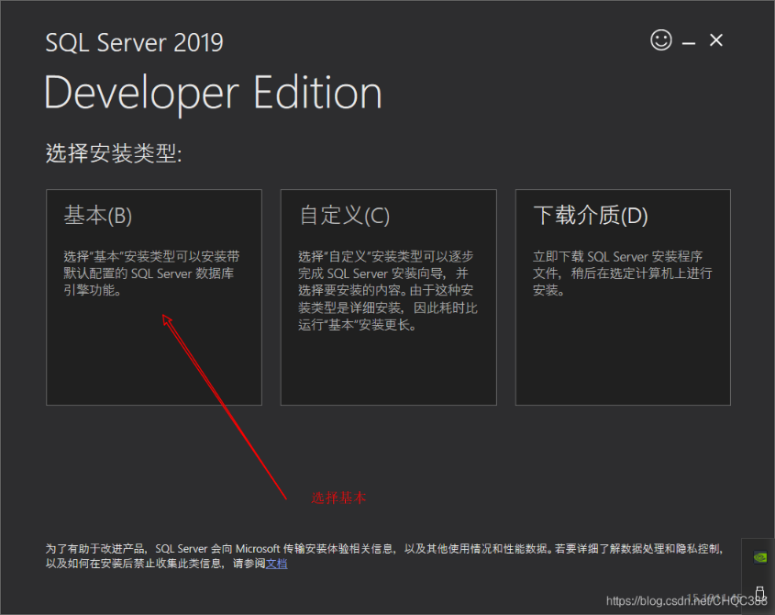

4、Choose language (my example is simplified Chinese)

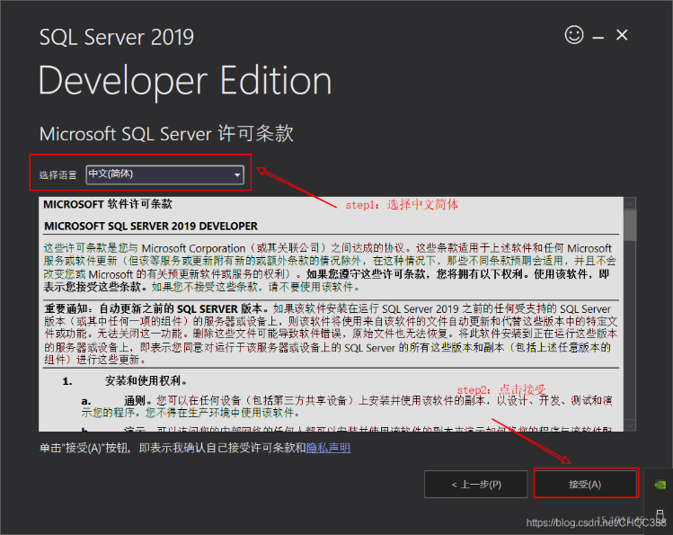

5: According personal demand, setting your path

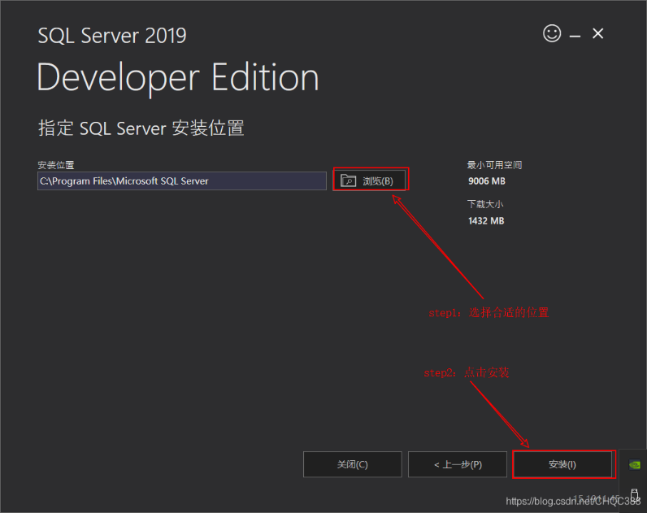

6：waiting for finishing installing

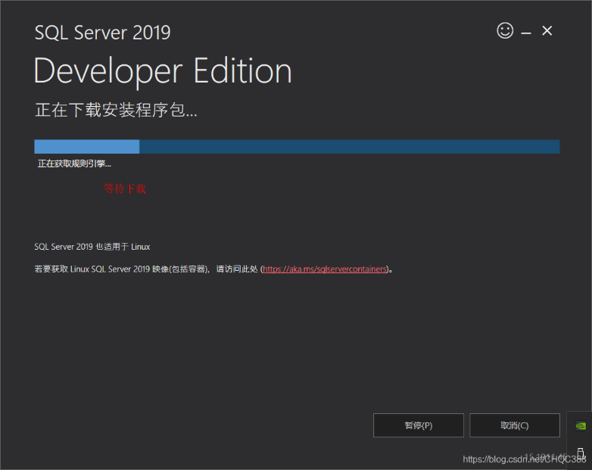

7、Install the SSMS, link is in step I, remember setting your path.

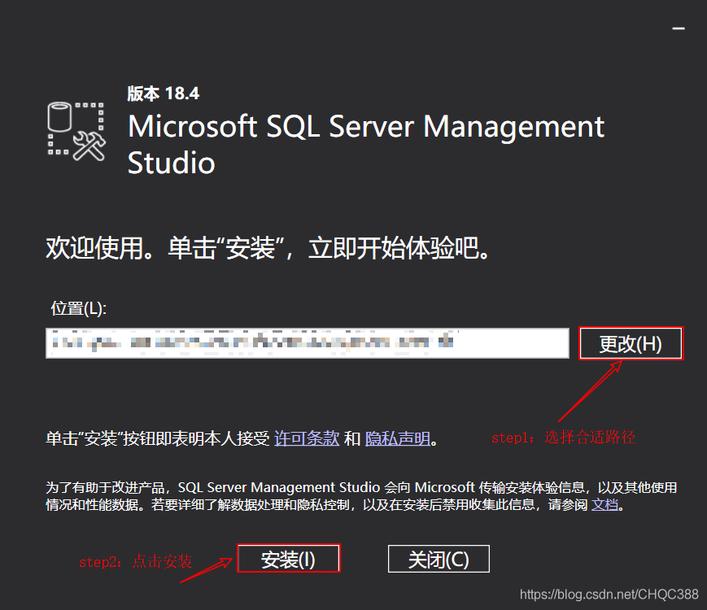

8: waiting

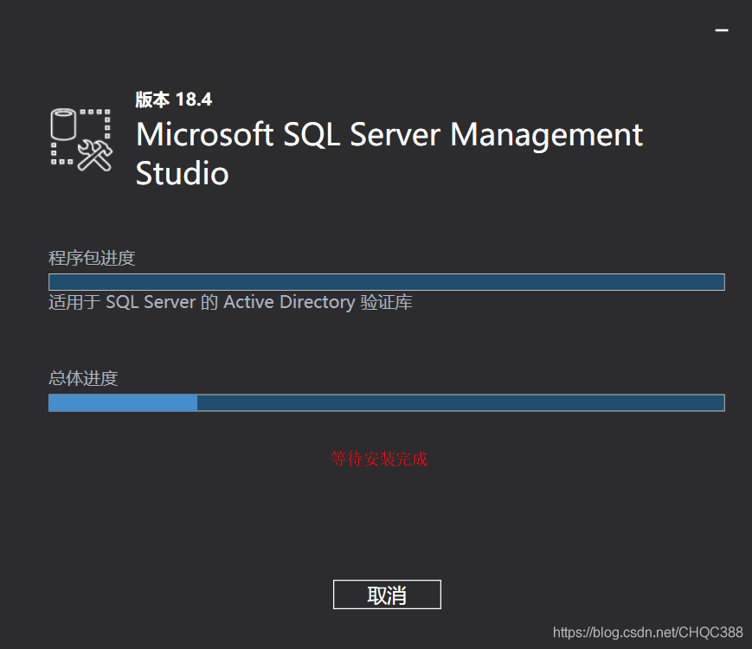

9: Running SSMS firstly, click it in Windows menu.

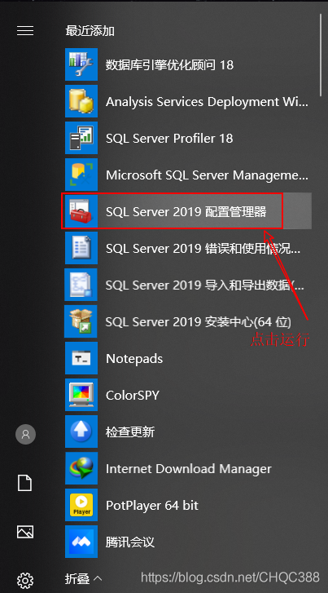

10: Click the SQL Server network configuration->protocols for MSSQLSERVER->enabled TCP/IP

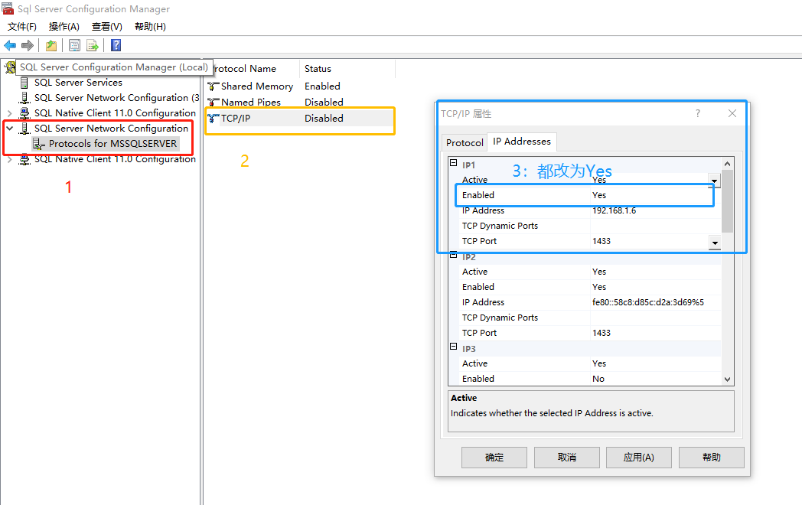

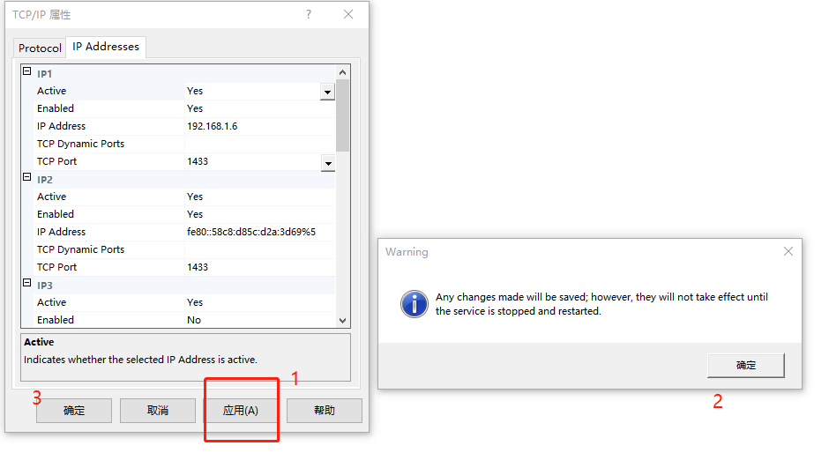

11: running SQL Server2019

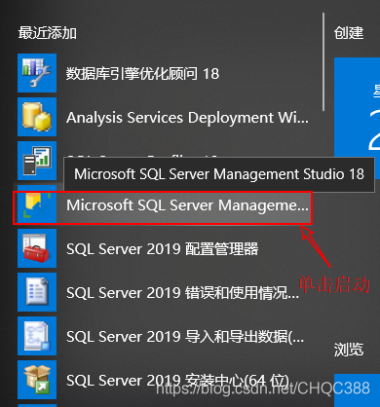

12、click connecting directly

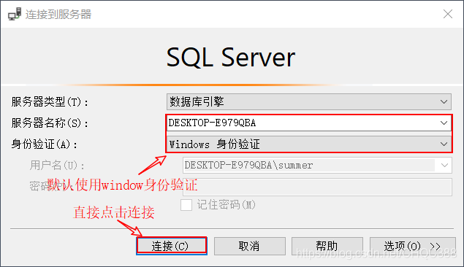

13 If the string shows in your menu column, it means that connect successfully

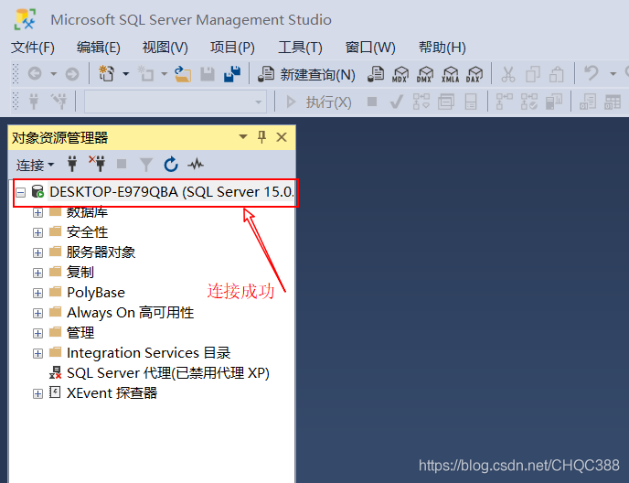

14 Right click and open the attribute

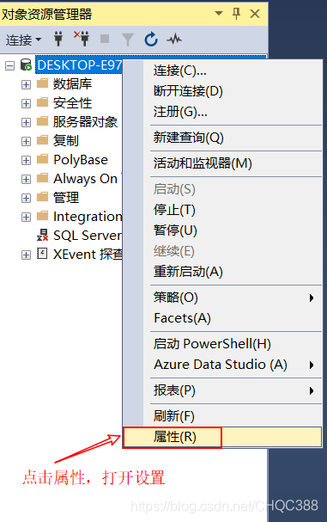

15 Security->choose SQL Server and Windows Authentication

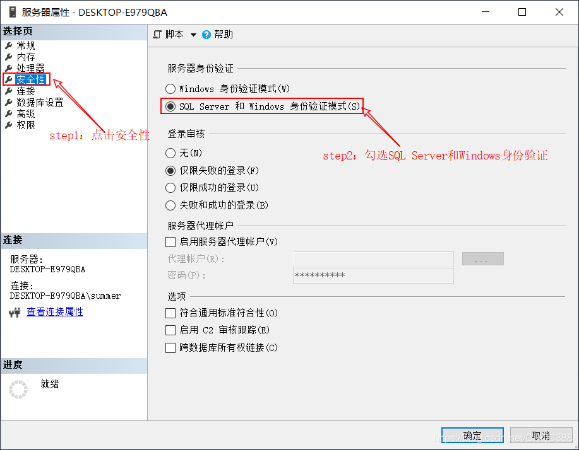

16 Click connecting, then allow remote connections to this server

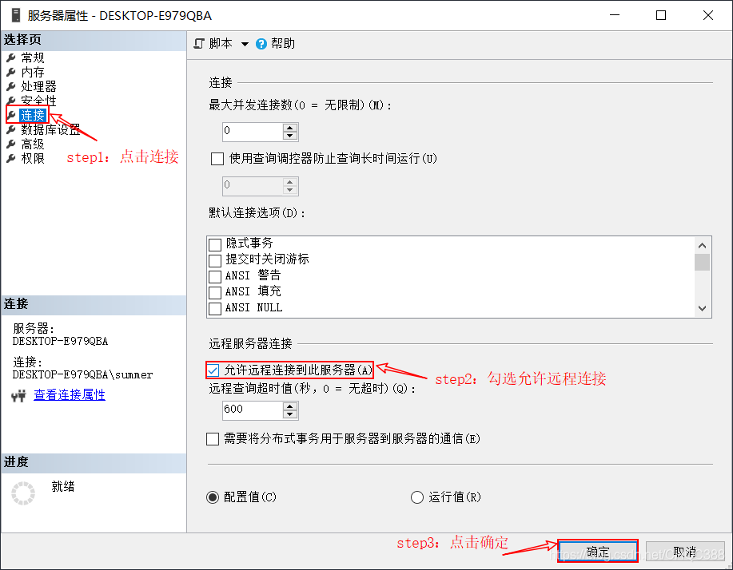

17 running SSMS



18 Follow the step in picture number, the second step is right click to configurate

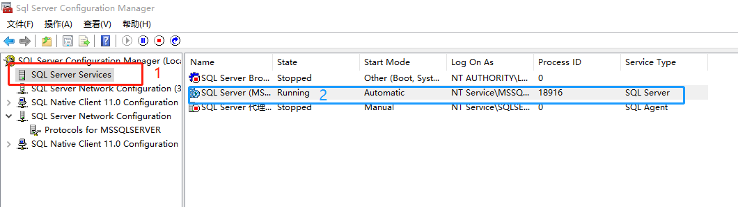

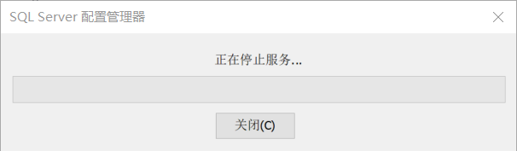

19 Back to SQL Server2019, choose security, login name is ‘sa’, and right click to open attribute

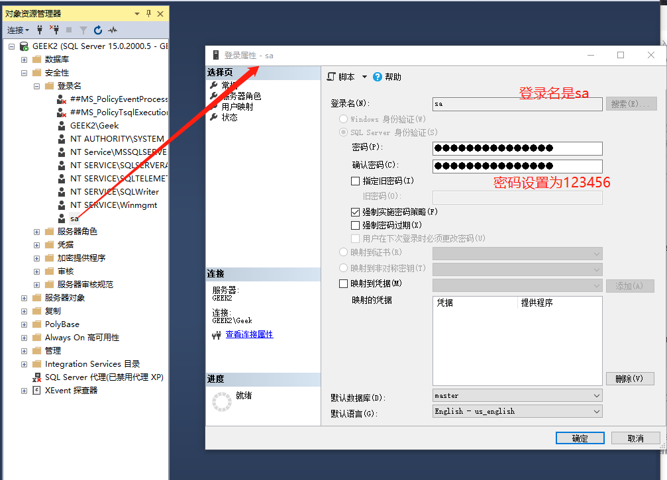

20 configurate according the follow step

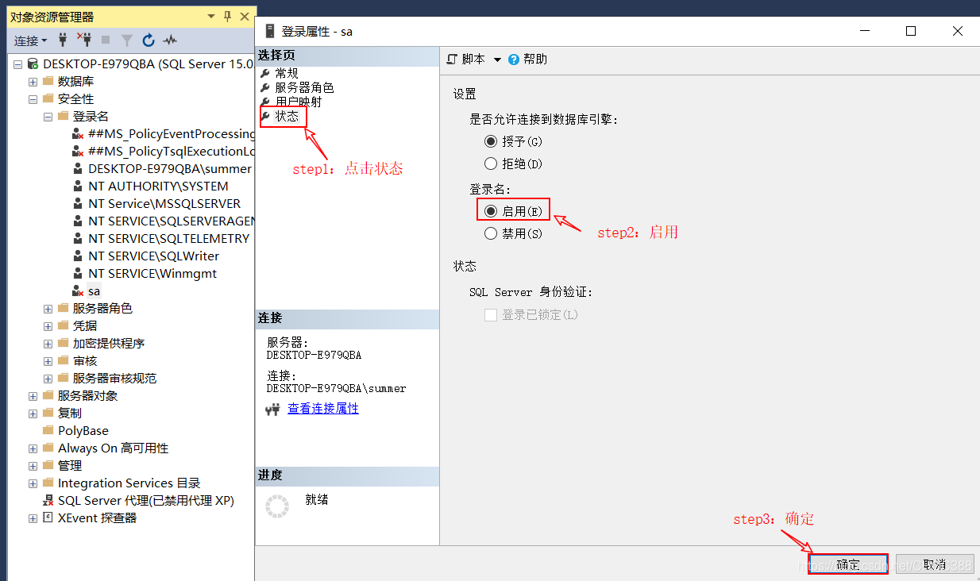

21 Close all windows and reconnect, but login name is still ‘sa’, password is ‘123456’

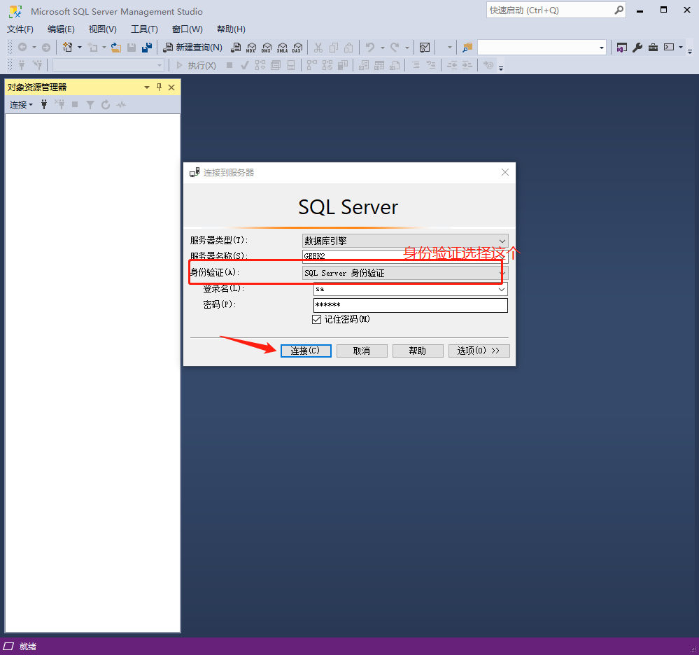

22 log in successfully and create new database

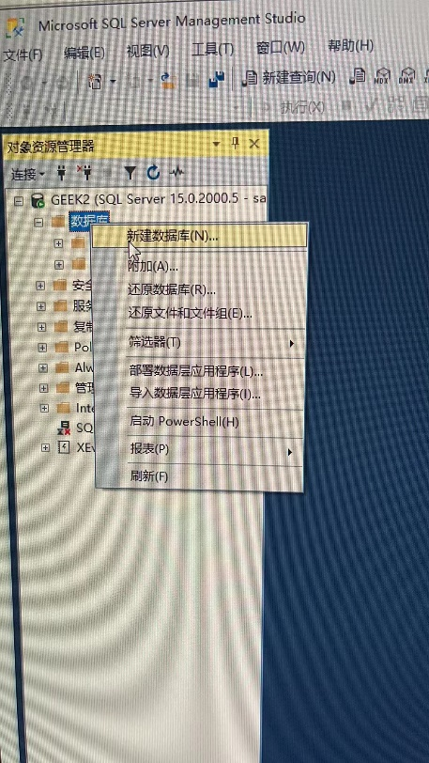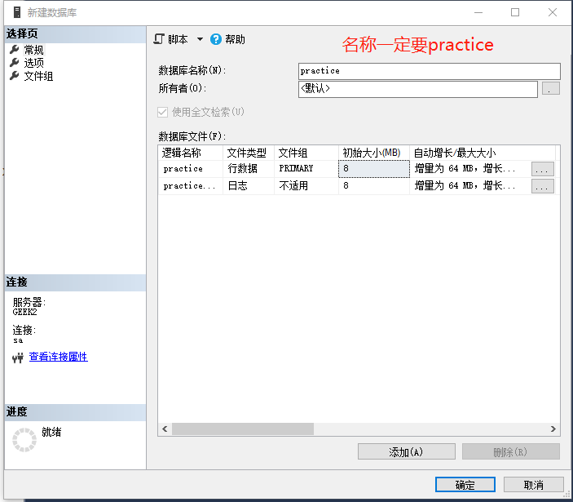

24 Open folder: practice, run these code following the order

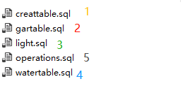

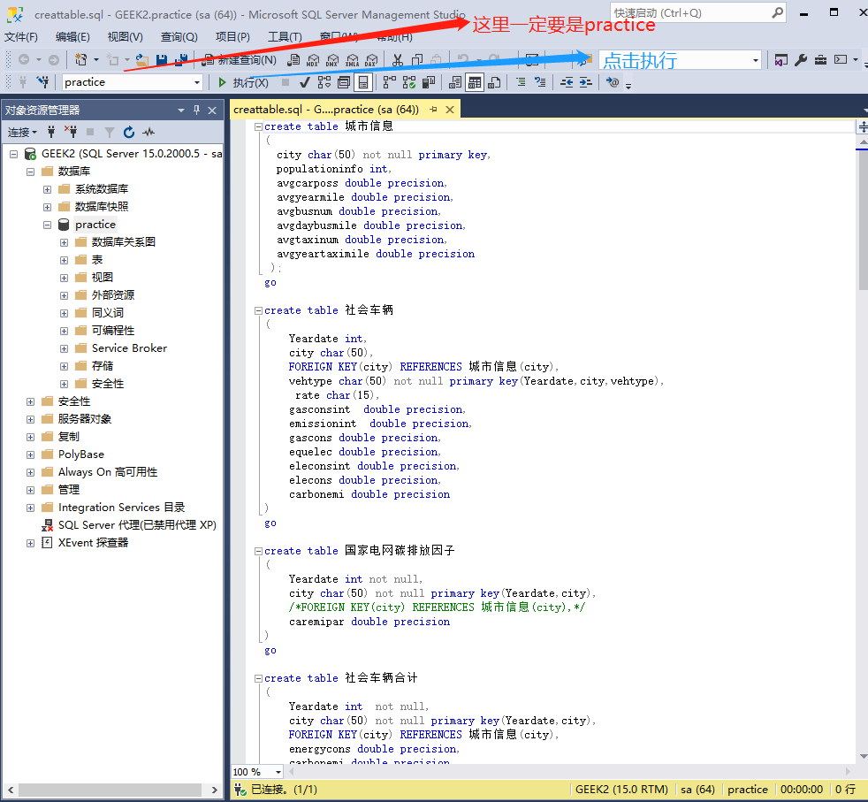

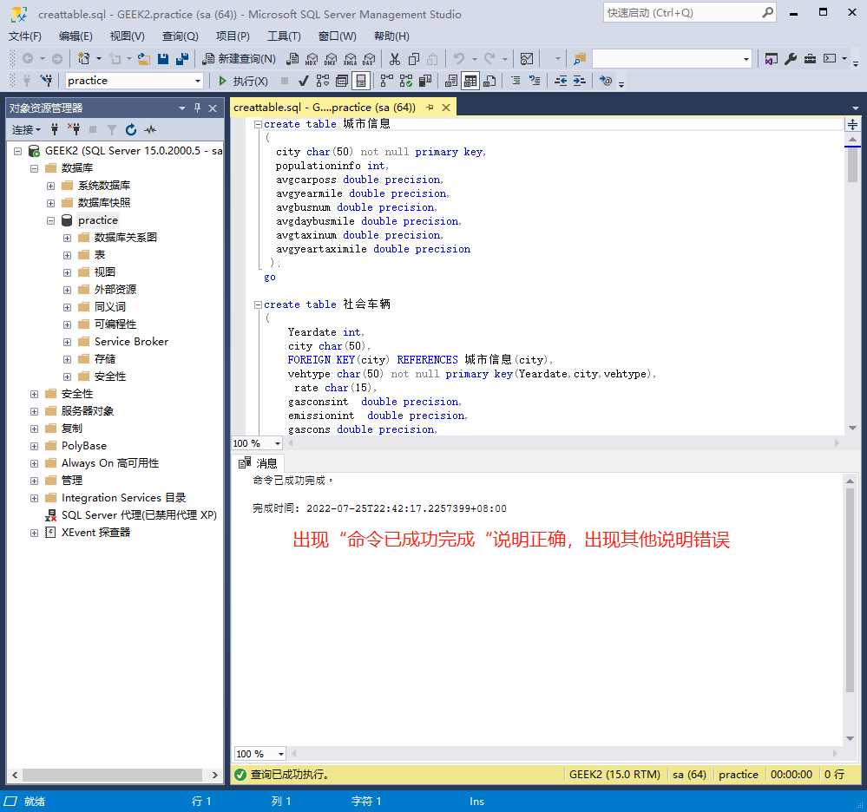

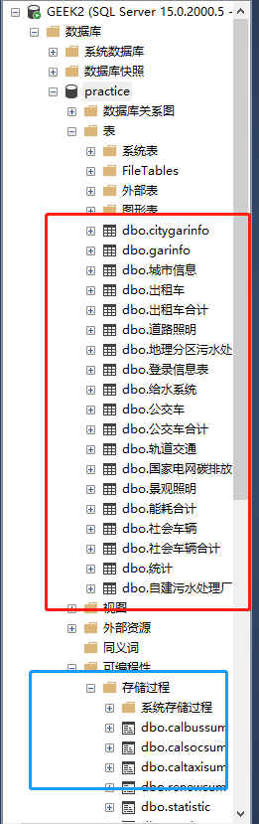

(if you configurate rightly, your database should appear this files）

Finishing configuration

Login name: 147258 password: 123456